This doc is from the below “Air Dave” youtube video, and then a Mike Busch one.
https://www.youtube.com/watch?v=DnOlrqReesk
General notes:
clean end of borescope with alcohol and a swab.
Prep:
Remove cowling
Remove top plugs
Cylinder temp below 140 degrees (room temp is ideal)
Start with cylinder #1 at bottom dead center (ie, piston farther away from valves).
Always go in same cylinder order 1-3-2-4 (front right, back right, front left, back left as viewed from pilot seat).
Photo order:
Piston, EV (exhaust valve) face, Intake valve (intake valve) face, EV seat, EV guide, IV seat, IV guide, cylinder wall
4 strokes take 2 crankshaft revolutions. So, 3000rpm = 1500 complete cycles in a 4 stroke (intake, compression, power, exhaust).
A 4 cylinder is completing one of the 4 strokes at all times.
Pre-ignition: too hot inside cylinder and it detonates before plug gires. Usually on 1 cylinder, ie the hottest one on the EGT/CHT. Cause: hot exhaust valve or hot spot in combustion chamber.
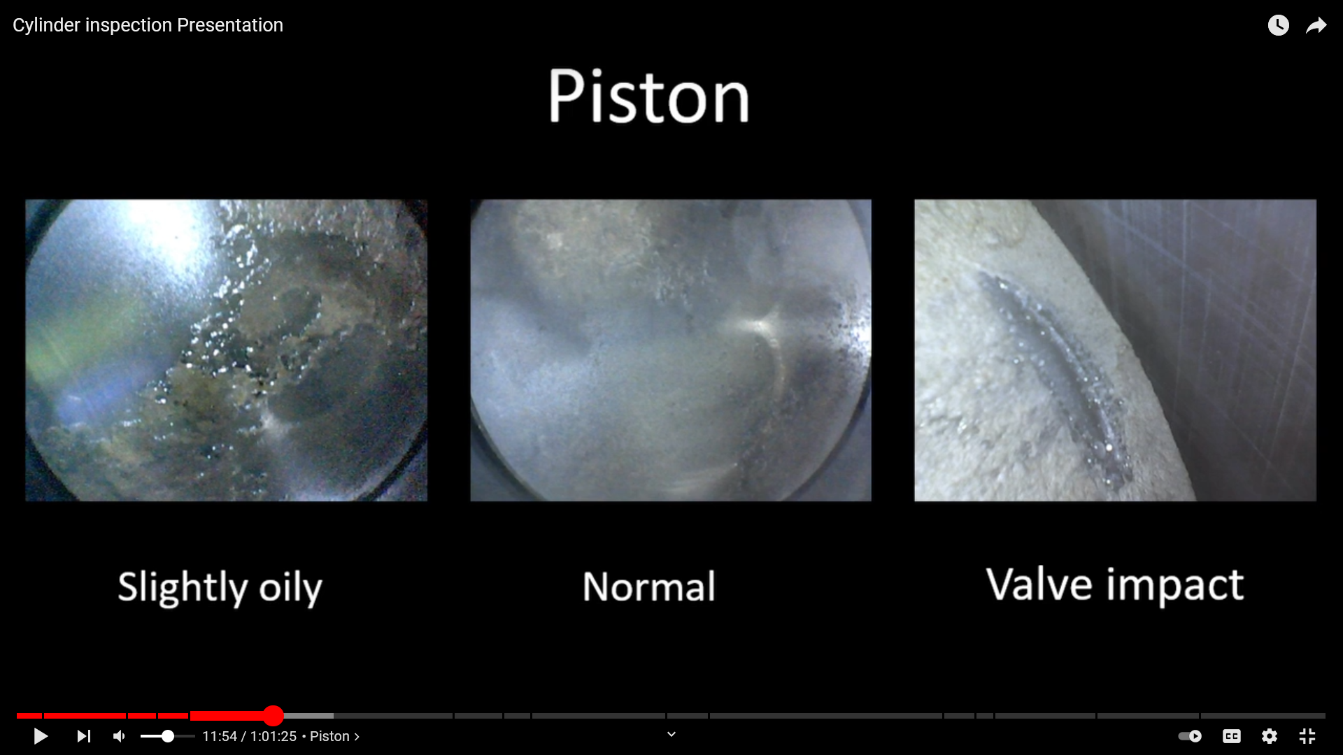
Generally no issues with piston. The slightly oily pic is fine usually, but if you are burning oil and not finding it on the belly or anywhere else, this could be the cause.
Normally the piston is dry but varies depending on engine time, ROP, LOP, etc.
The Valve impact on the right, the exhaust valve could have deposits on it causing it to stick, which then might lead to that half moon looking blemish in the right pic.
Also looking for piston crowning.

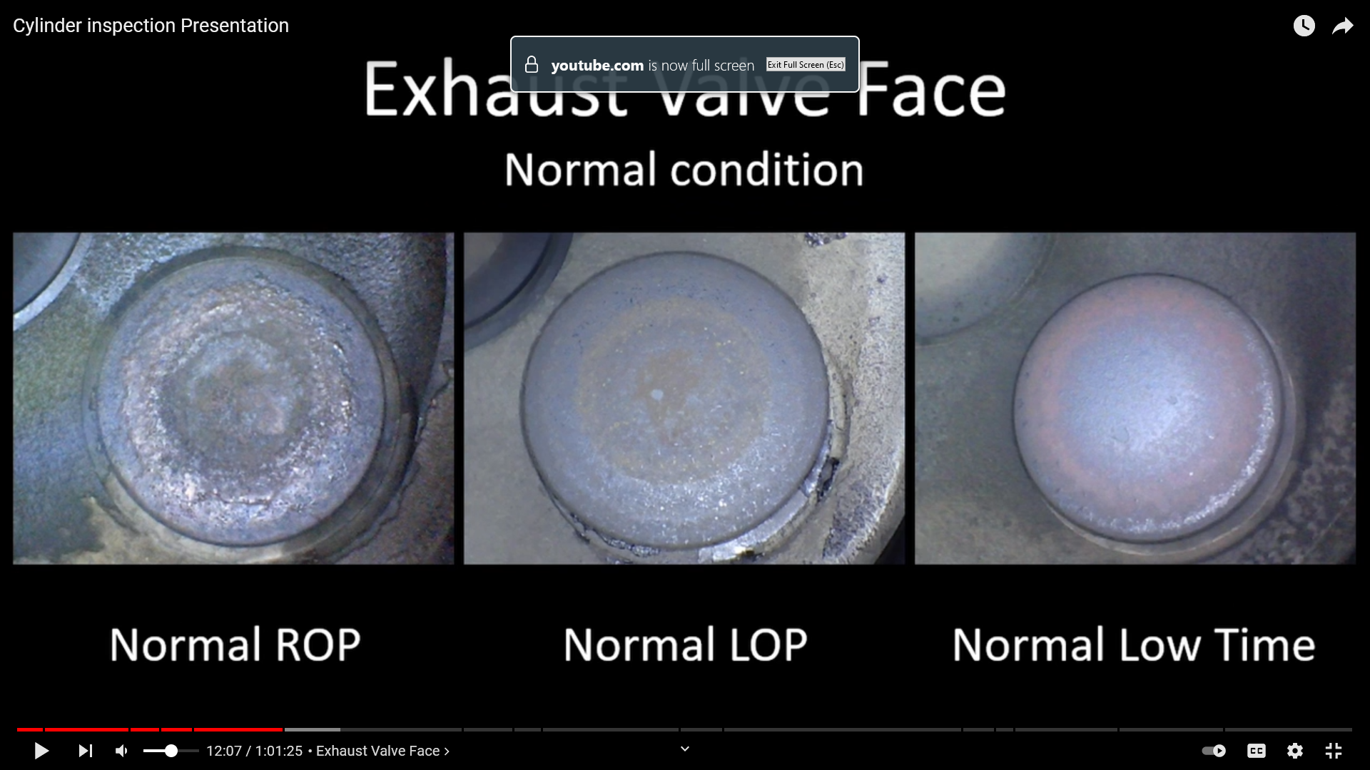
Most important, especially for continentals (with regards to needing a cylinder replaced).
Look for “burnt pizza”
NOTE: the white stuff on the lower right edge of the far right pic is a reflection from the camera
exhaust valve is supposed to be red! The red color is from exhaust deposits on the face of the valve, and such deposits are perfectly normal. In fact, the cooler the valve is operating, the thicker the deposits and the more intensely red the valve appears. It’s actually the absence of red deposits that tells us the valve is heat-damaged and leaking.
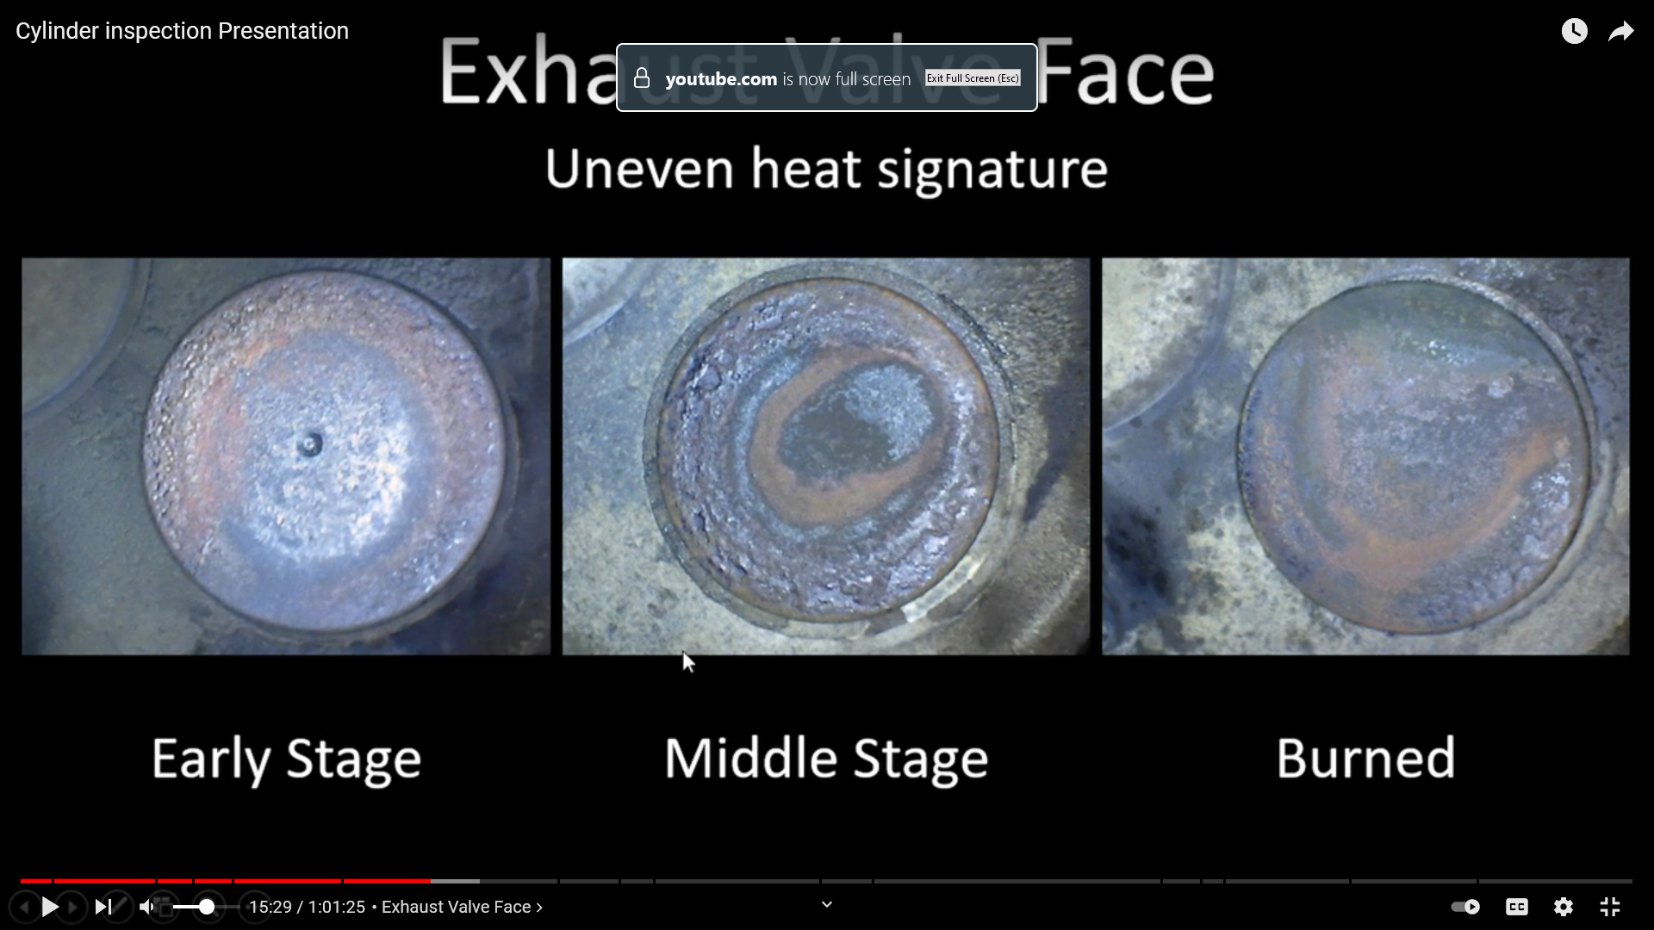
Left pic – hot spot at the 7 oclock position. If left to progress, will look like middle pic.
Right pic – deposits are in bell shaped curve. Starts to turn green. “green means stop”. Make sure color isn’t green from weird camera lighting also.
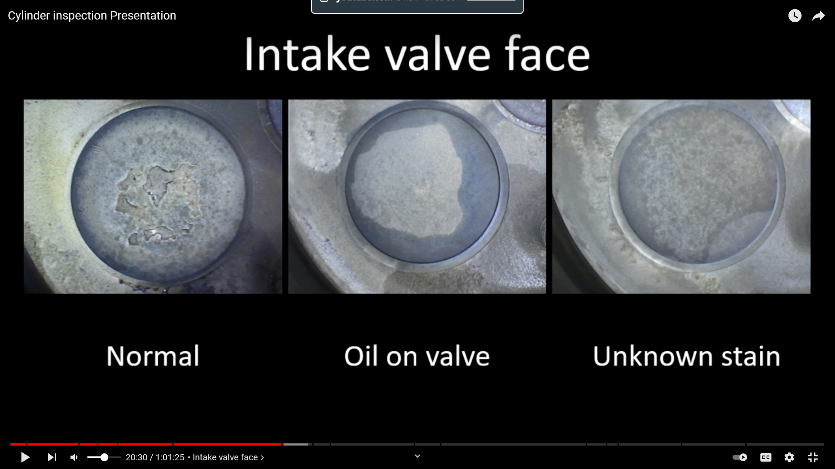
Usually see some deposits on the intake valve, which is fine (unlike exhause). IV runs cool.
The “oil on valve” is more common if the engine has been sitting awhile after its been run, and before pics.
Unknown stain in bottom right he said is probably nothing, and if you ran the engine for a bit, it’d probably go away.
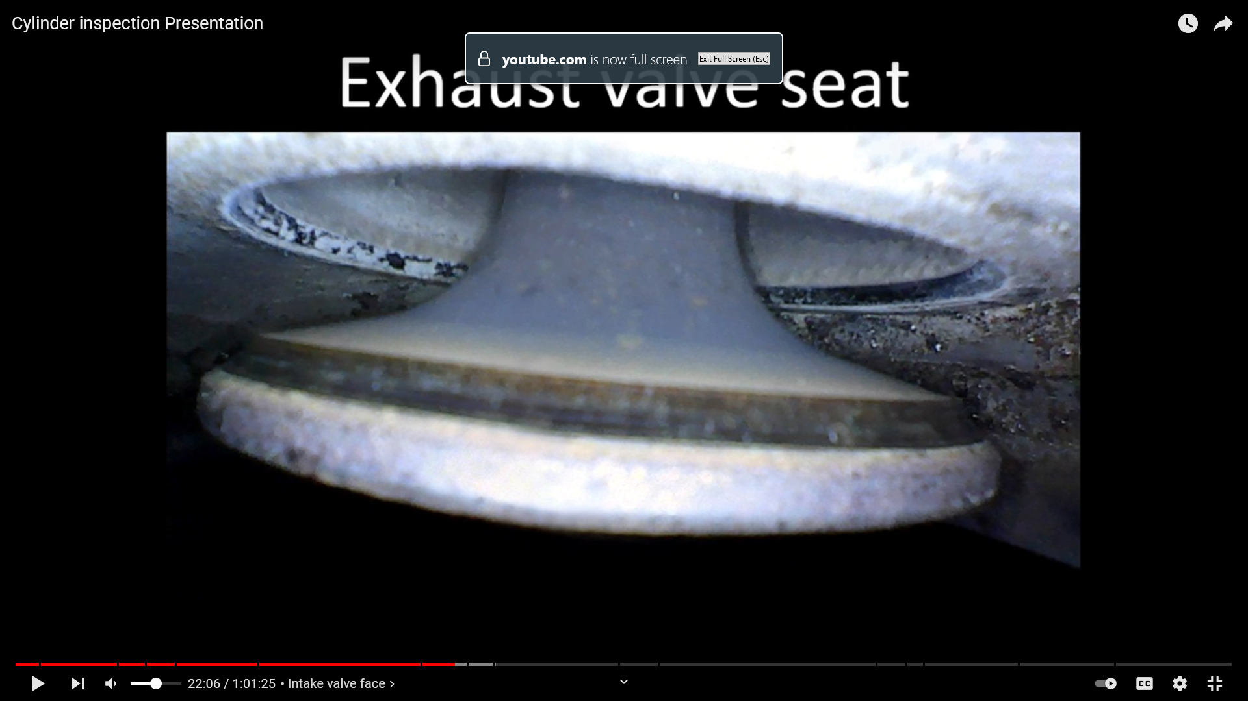
Normally, you only see half a pic. This is one where 2 were photo shopped.
On the right, the seat is the black shiny ring towards the top (that the valve goes up and touches), and on the left you can see white stuff on the seat, which are deposits.
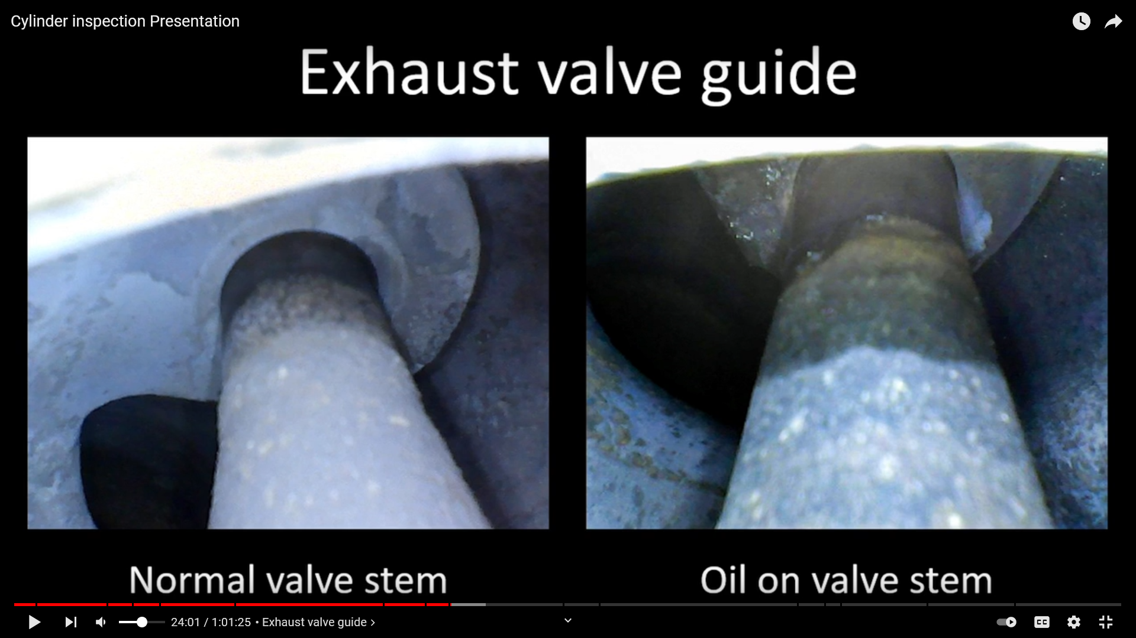
Oil on stem is common for high time cylinders. And if you let it set for awhile after running and before pics.
If you are not using oil and things look like one of those pics, keep running it. Play between the valve stem and guide is common on engines over 200 hrs.
He keeps talking about lapping a valve in place (which means to reseat it), or possibly pulling an individual cylinder and having it rebuilt.
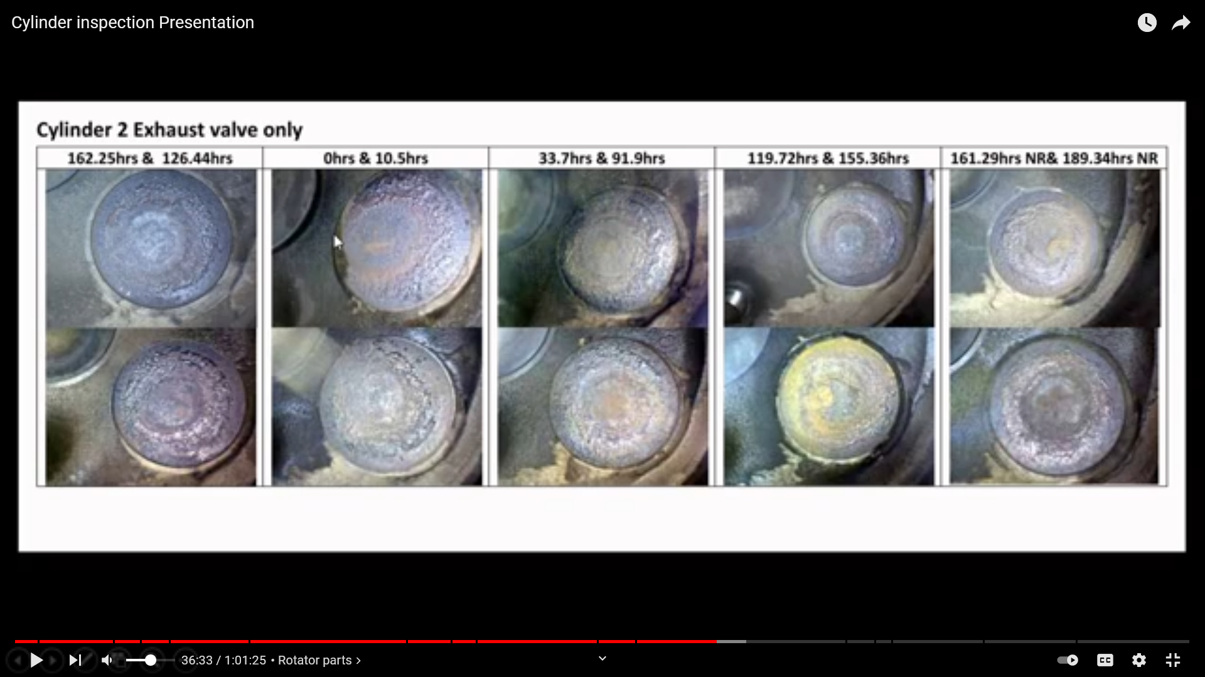
This is all pics of the same valve. The first, 162 hr prior to lapping the valve. Then 126 hrs prior. Then 0 hrs, which is when he lapped the valve, then the rest are pics of that many hrs after lapping the valve. The lapping process should redistribute the heat more uniformly and reduce hot spots, which you can see over time after lapping how it starts to get more symmetrical again. You can see at the 119 hr mark, it is starting to move again. He said its due to the rotators not being changed when you lapped it. The rotators go on the other end of the valve and control, well, rotating the valve when it opens and closes. At the 155 mark, he changed the rotator, and then you can see it start to make a good heat signature again at 161 and 189. You can also see in the 155 pic, the spot at the 9:00 position, then in the 161 pic you see that spot move to 3:00. That tells you it is getting rotated. You can kind of see in some of the earlier pics it doesn’t appear to be rotating, which the guys said had he known about rotators, he would have changed it initially when he lapped it. Basically the rotators are cheap, and if you are going to lap it, you should change rotators. Notice how the 189 photo is now a normal ROP photo.
Lapping is taking lapping compound and putting it on the valve and the valve seat, and then opening and closing a bunch to essentially wear down/off anything on them, so that they now sit together nicely, and distribute heat evenly again.
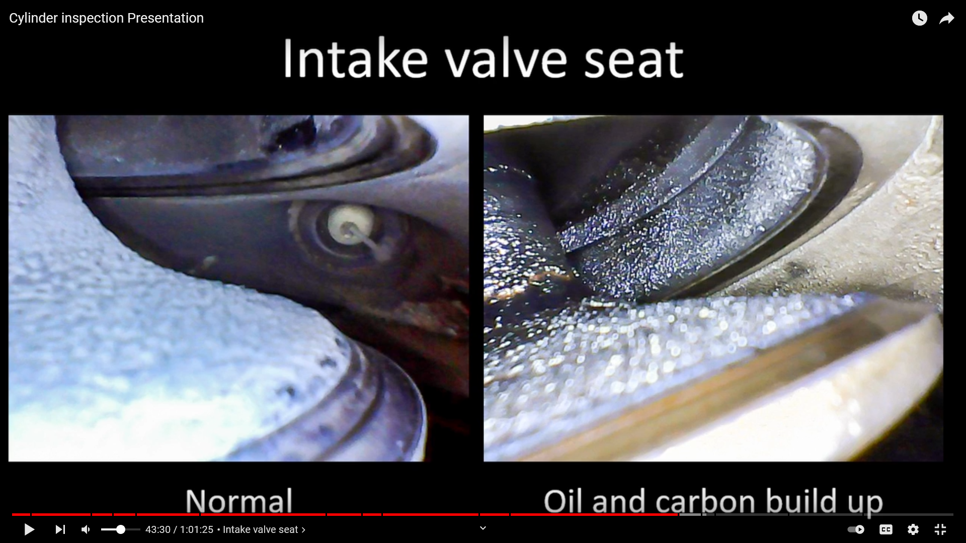
Usually not a lot of issues regarding this. Powdery lead buildup is normal. Ie, right side is a Lycoming engine. Usually more buildup on the back of Lycoming intake valves vs continental. But he wouldn’t pull one based on that, especially if you are not using excessive oil. If you are using a lot of oil, then maybe that valve guide is pumping oil into the cylinder which is getting burned off. The right is a typical high time Lycoming engine.
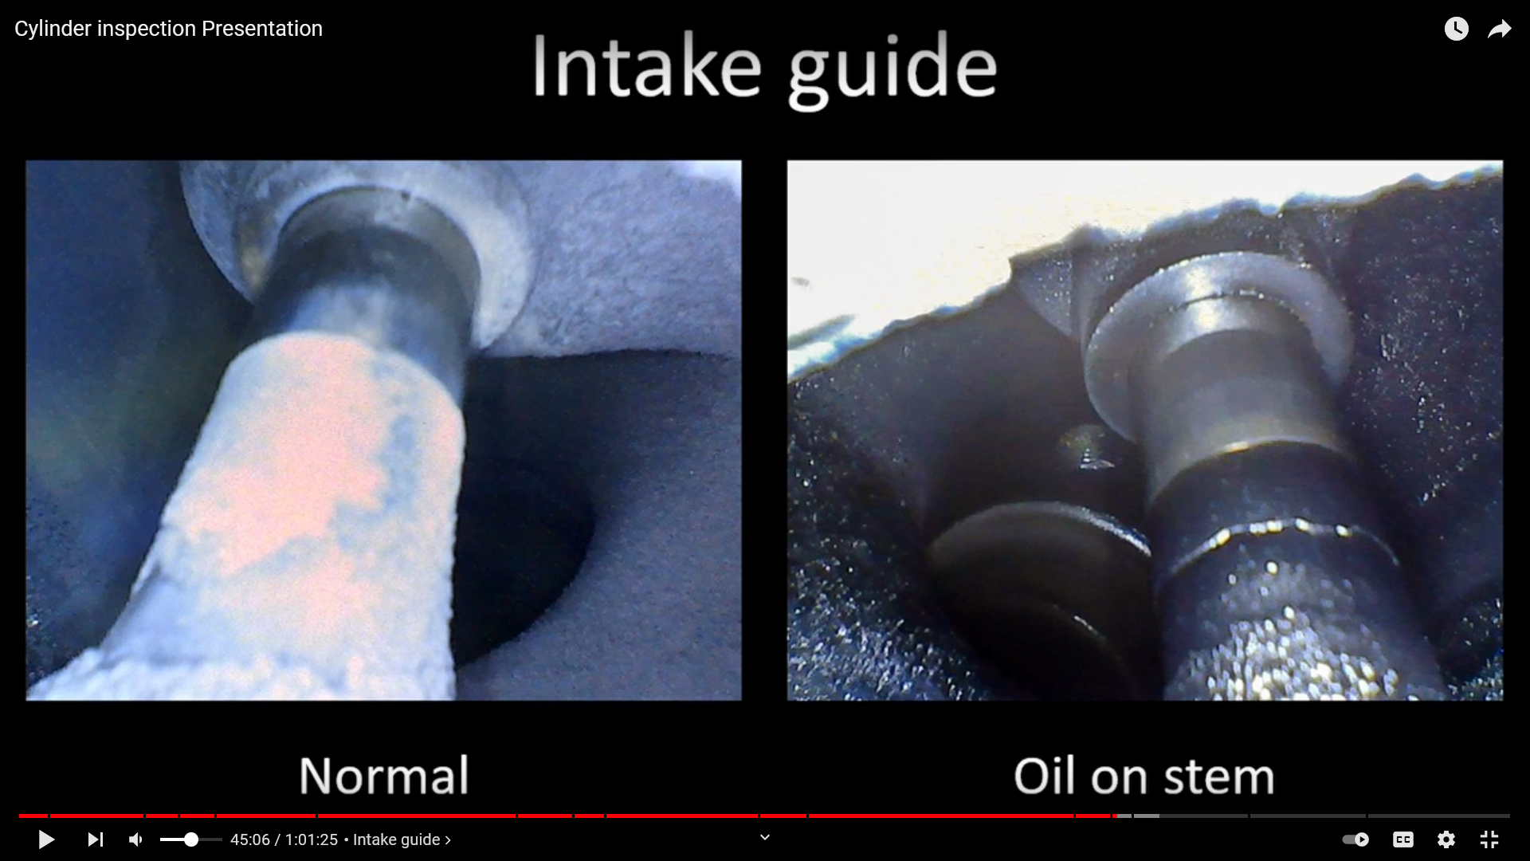
Left continental, right pic Lycoming. Same thing applies as before. The wet oil on the right is due to the plane sitting awhile after running it and before inspecting. Ie, normal.
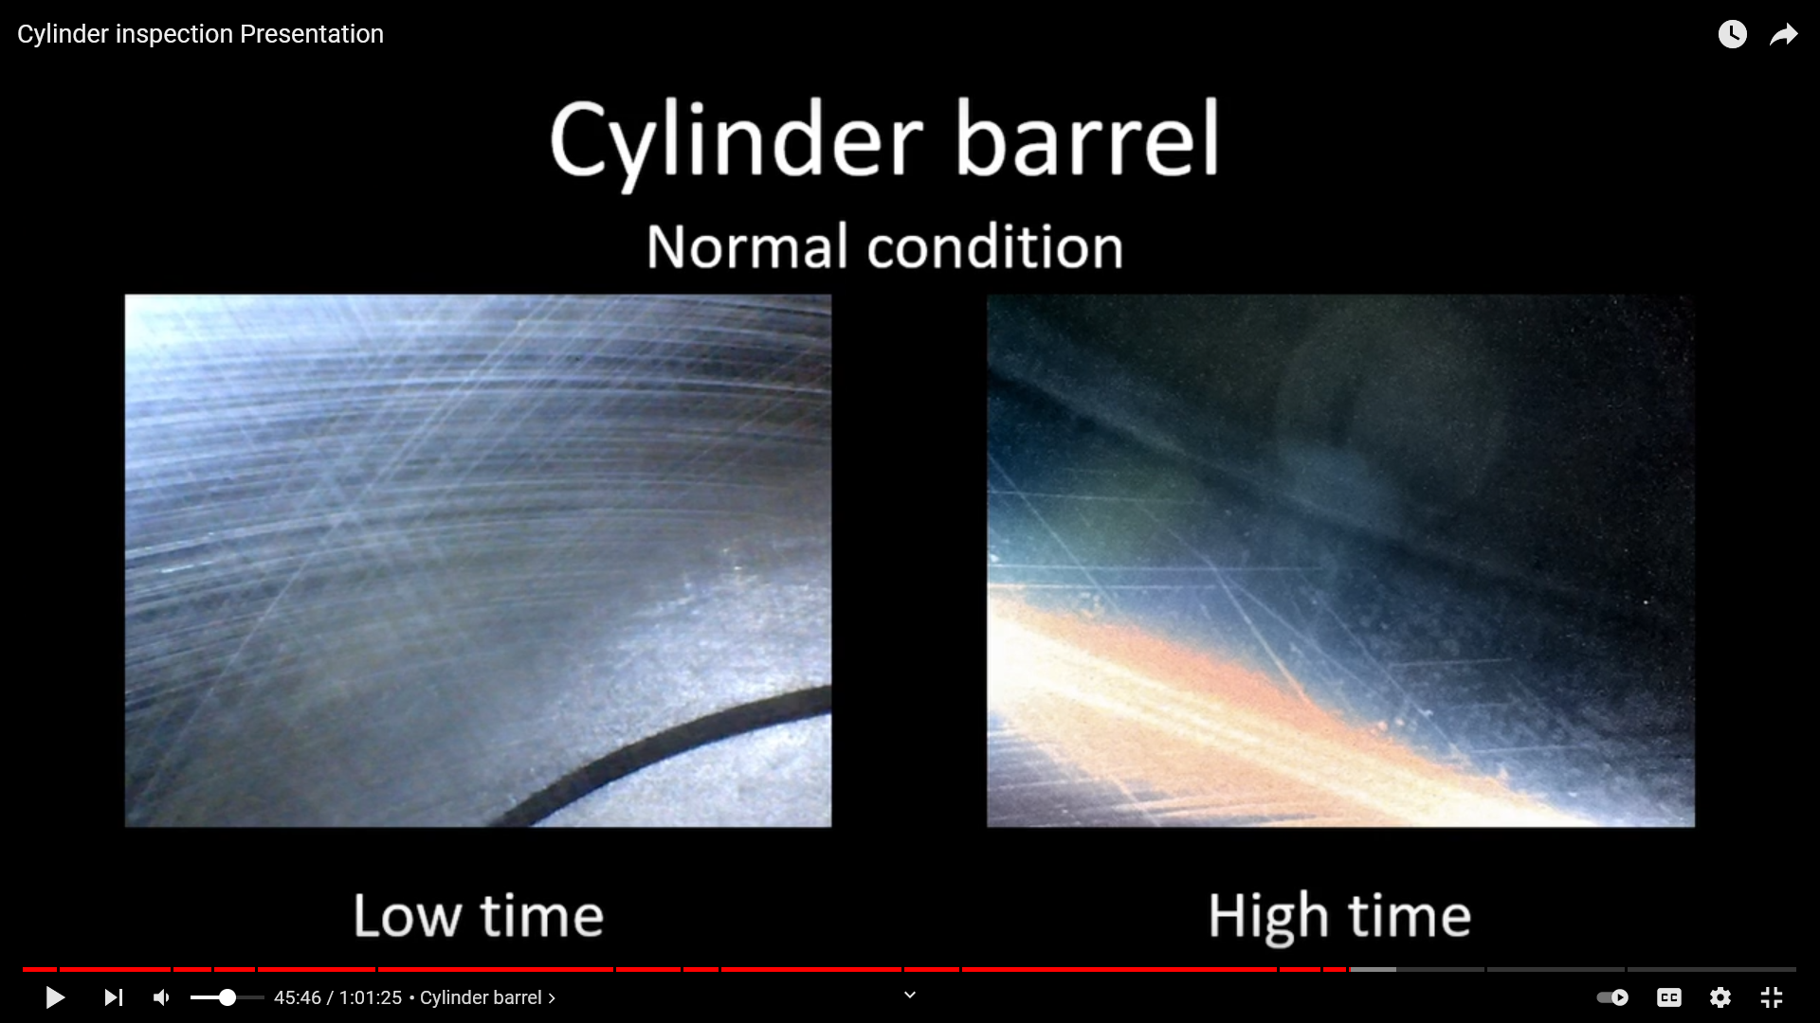
These are steel barrels, which is what that cross hatching is. That pattern wears away, ie the right pic. As long as you don’t have excessive oil consumption or metal in the oil filter, then continue on.
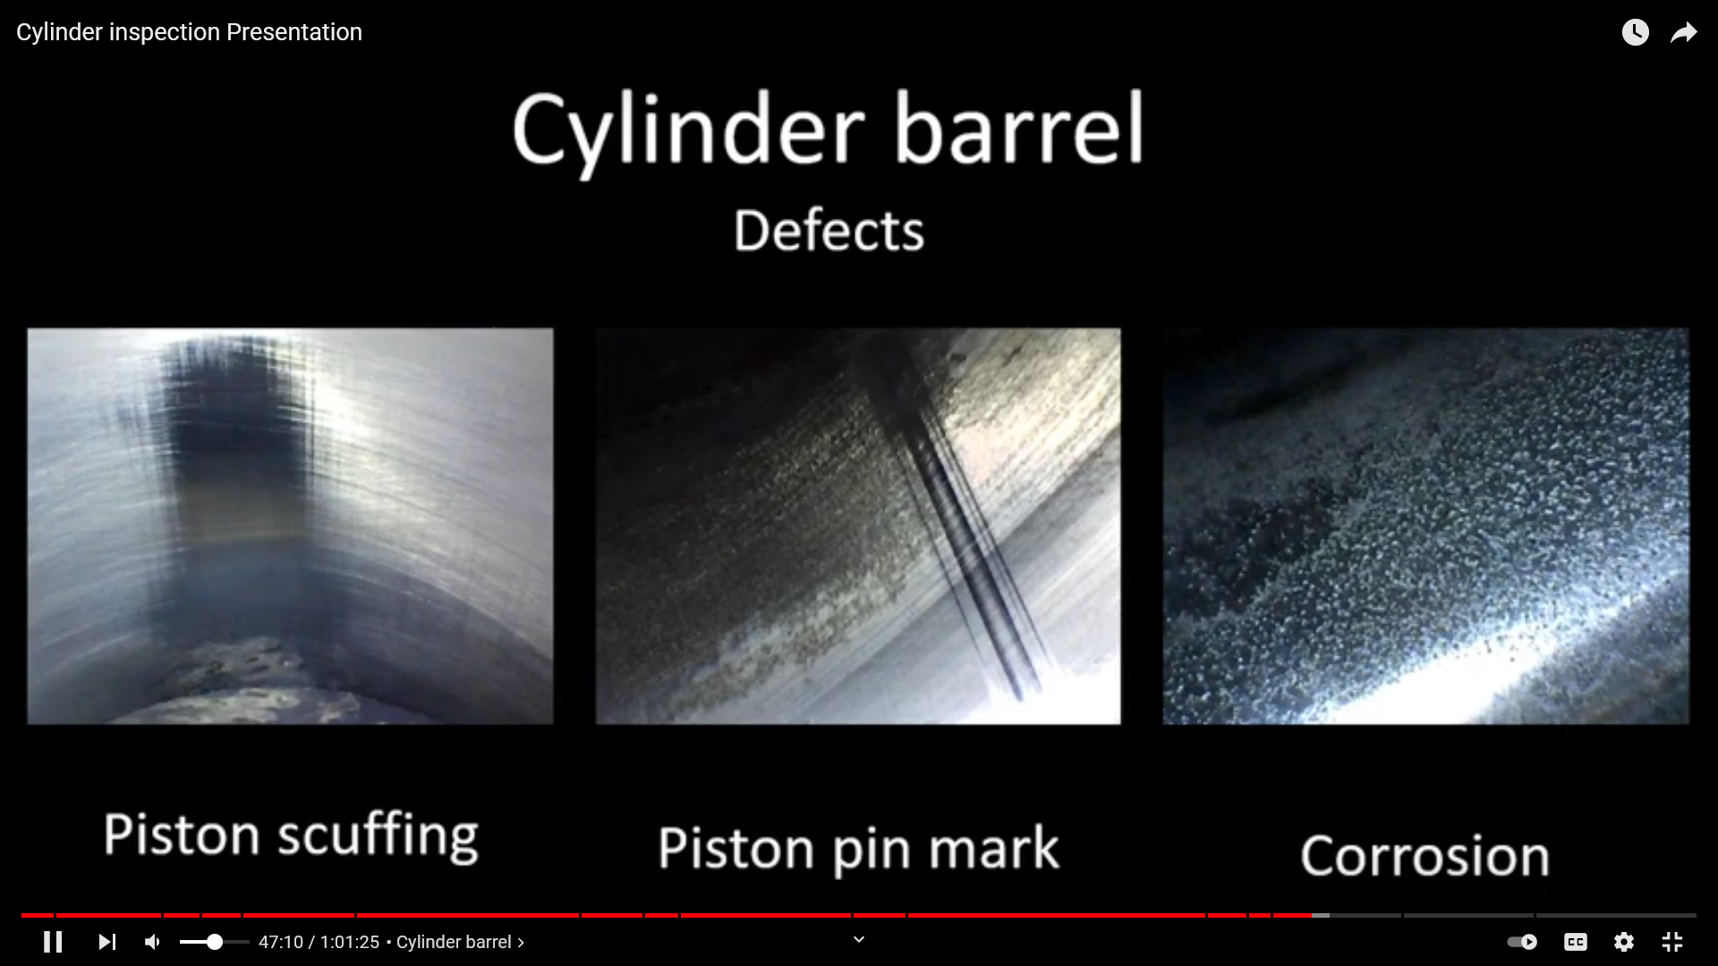
The left pic. Low time IO-390. Owner would go to high rpm way too soon after starting before engine gets warmed up. Ie, piston expands faster than cylinder barrel and causes a clearance issue.
Center / piston pin mark seems more common in Lycoming. Piston pin contacts the wall and creates metal. You can also see a lot of corrosion in that cylinder, which is also part of the issue.
Piston pin plugs always come back as aluminum, if you find it in your filter report.
Basically with all 3 pics above, if oil consumption is normal, and its not making metal, then just continue to watch and monitor. Otherwise, might consider cylinder replacement/rebuild.
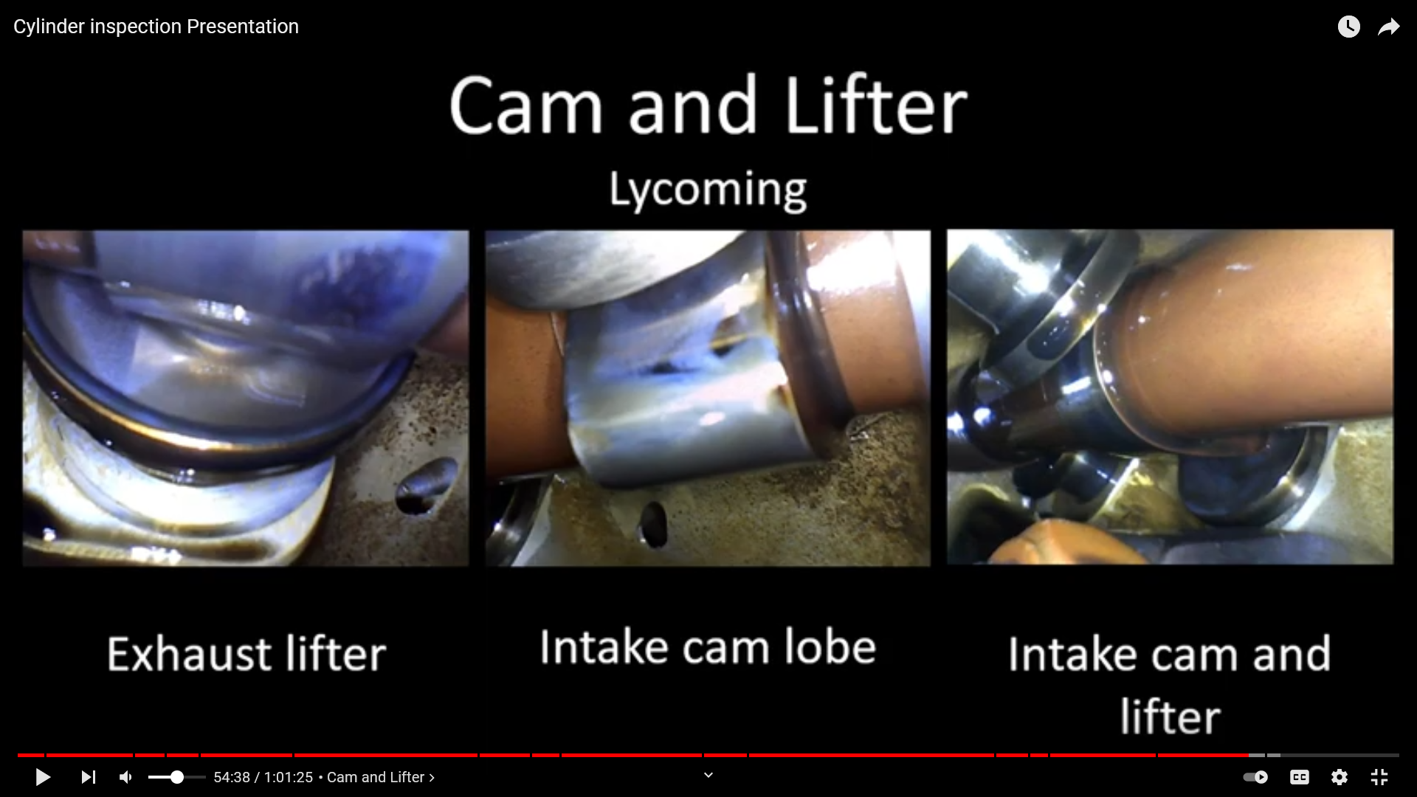
On some engines, you can stick borescope thru the oil filler tube and check out the cams and lifters.
Sort all your photos by cylinder. Make a separate folder for “cam & lifter” if you do it.
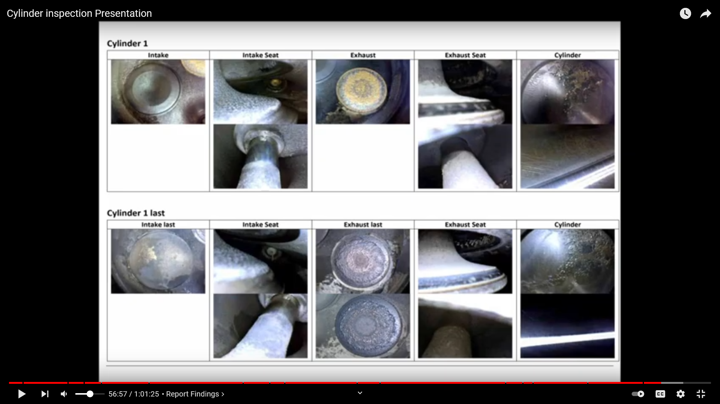
Sample report.
Why use a borescope vs simply compression testing? ANS. Compression testing is unreliable.
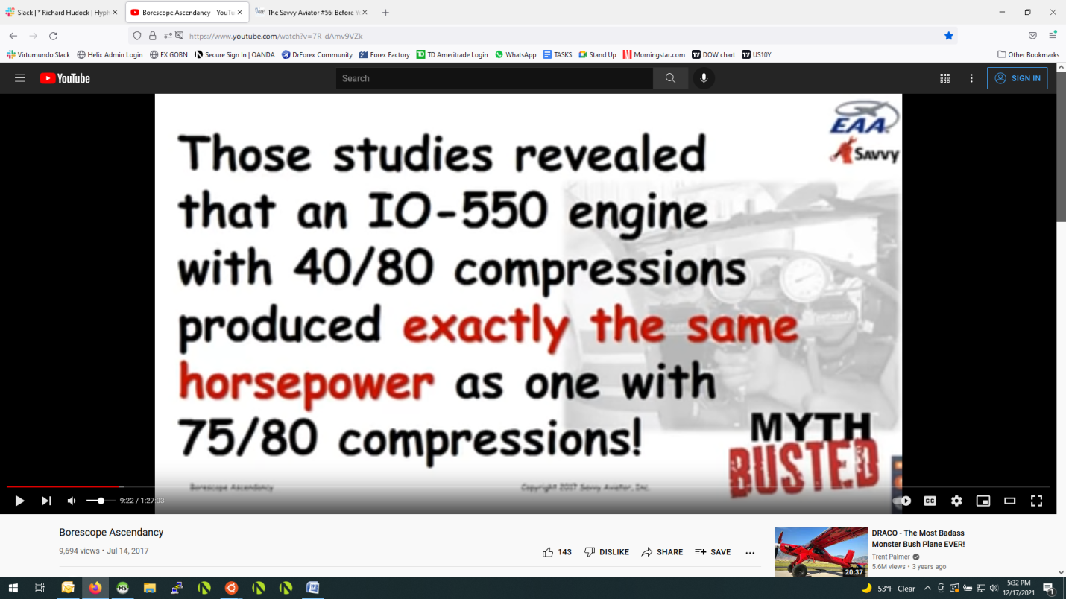
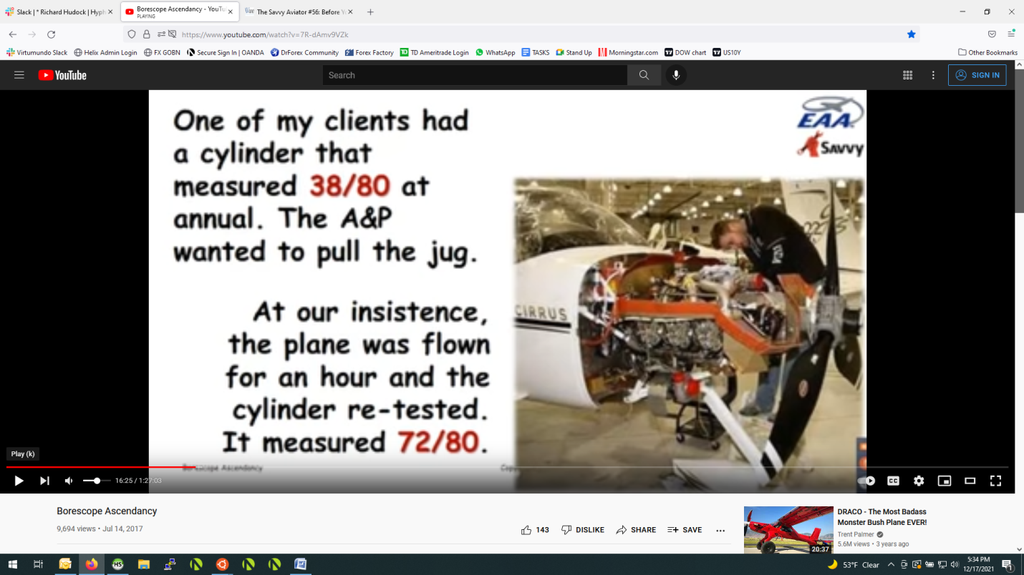
What are we looking for:
Exhaust valves and seats are the most failure prone. This is the only component in the cylinder that is likely to cause catastrophic failures.
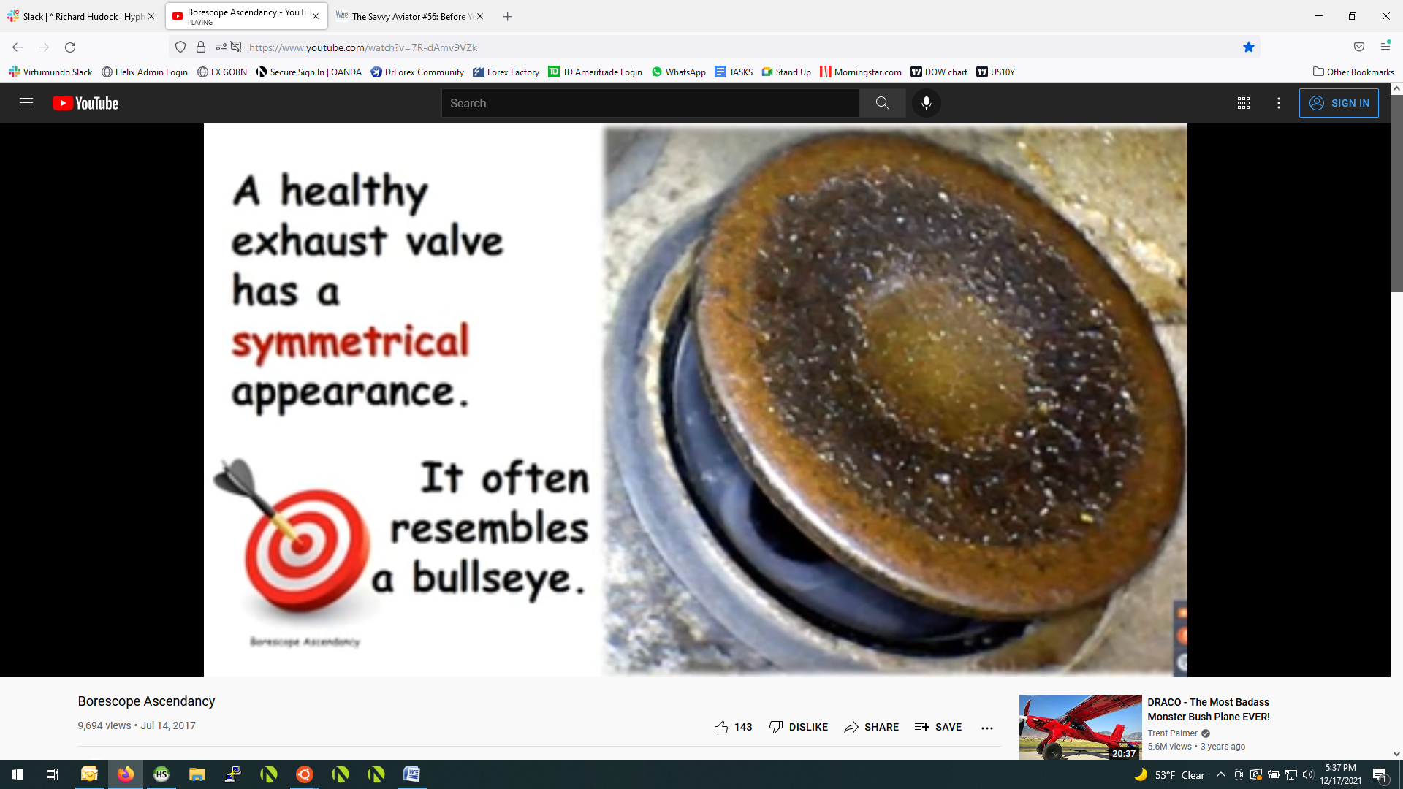
Again, looking that it is symmetrical, which means a symmetrical heat pattern and its running the same temp around the valve, and that tells us the valve is not leaking. There will be less deposits on the place where the valve is running hotter.
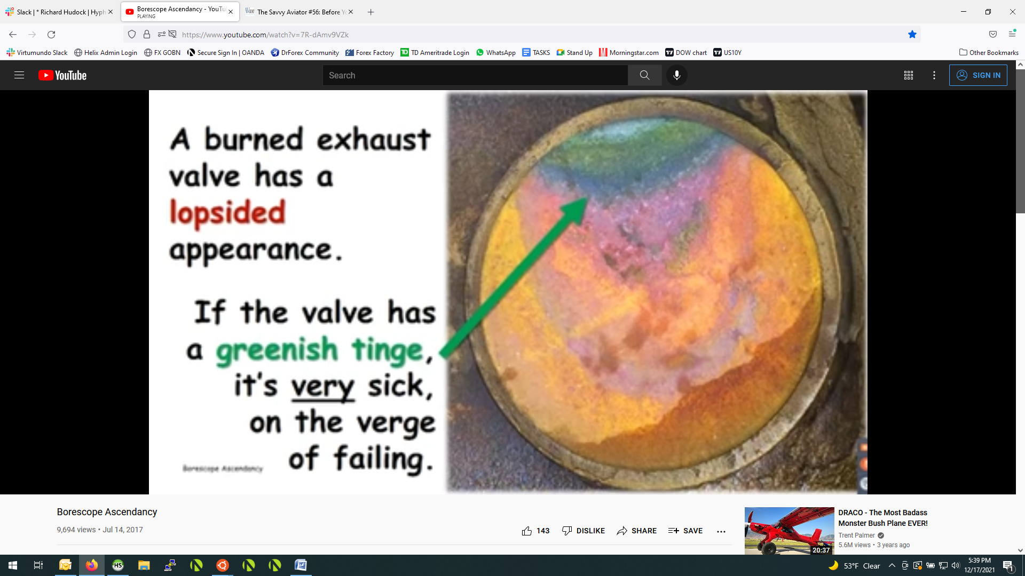
The way it would fail, is that a chunk of the valve from the hot area, ie at the 12:00 position, would break off, the valve would not seal, the cylinder compression would go to zero, and the cylinder would fail, meaning you know have a 3-cylinder engine.
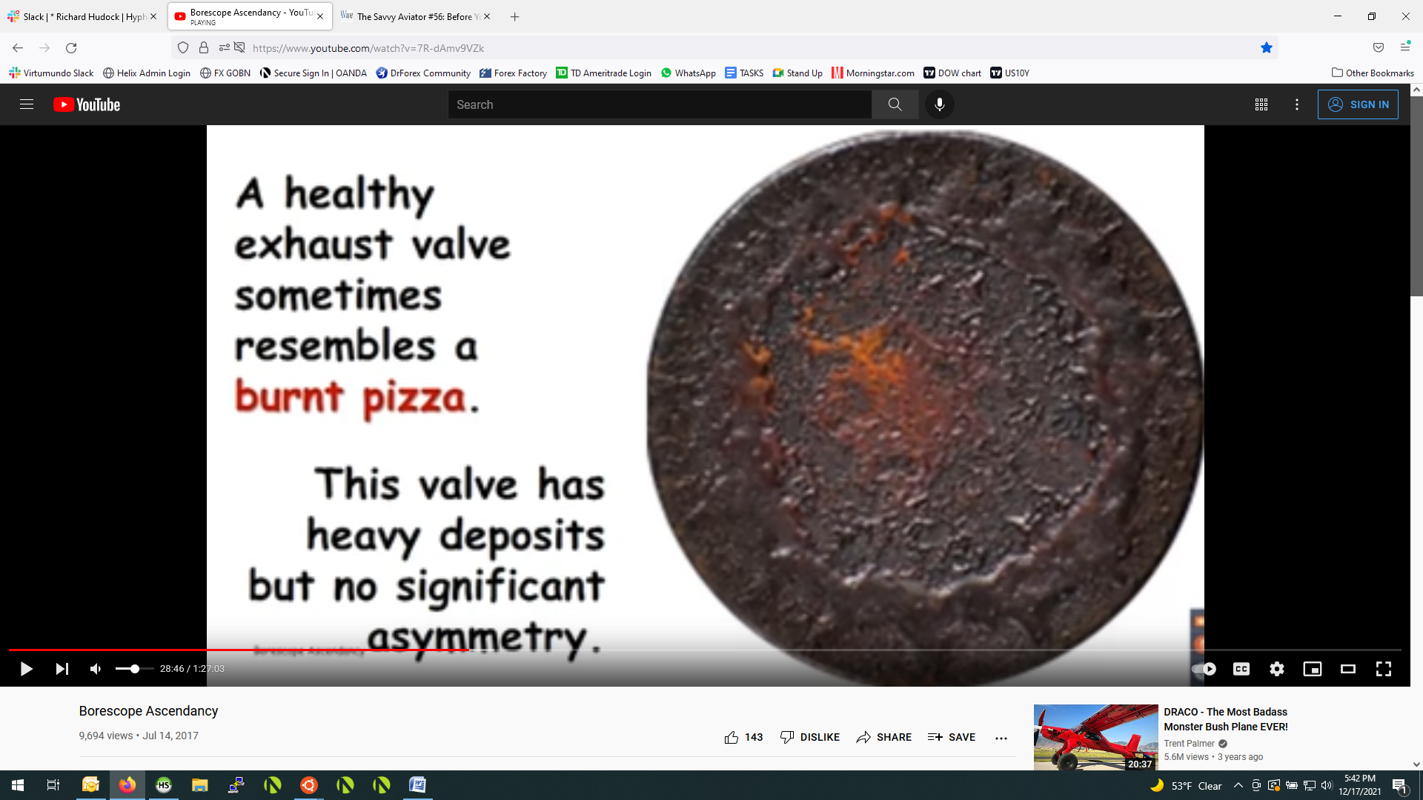
Also, in general, low deposits on the valve means that it has been run quite lean. So, that is probably the real answer as to whether N32020 is running too lean or rich.
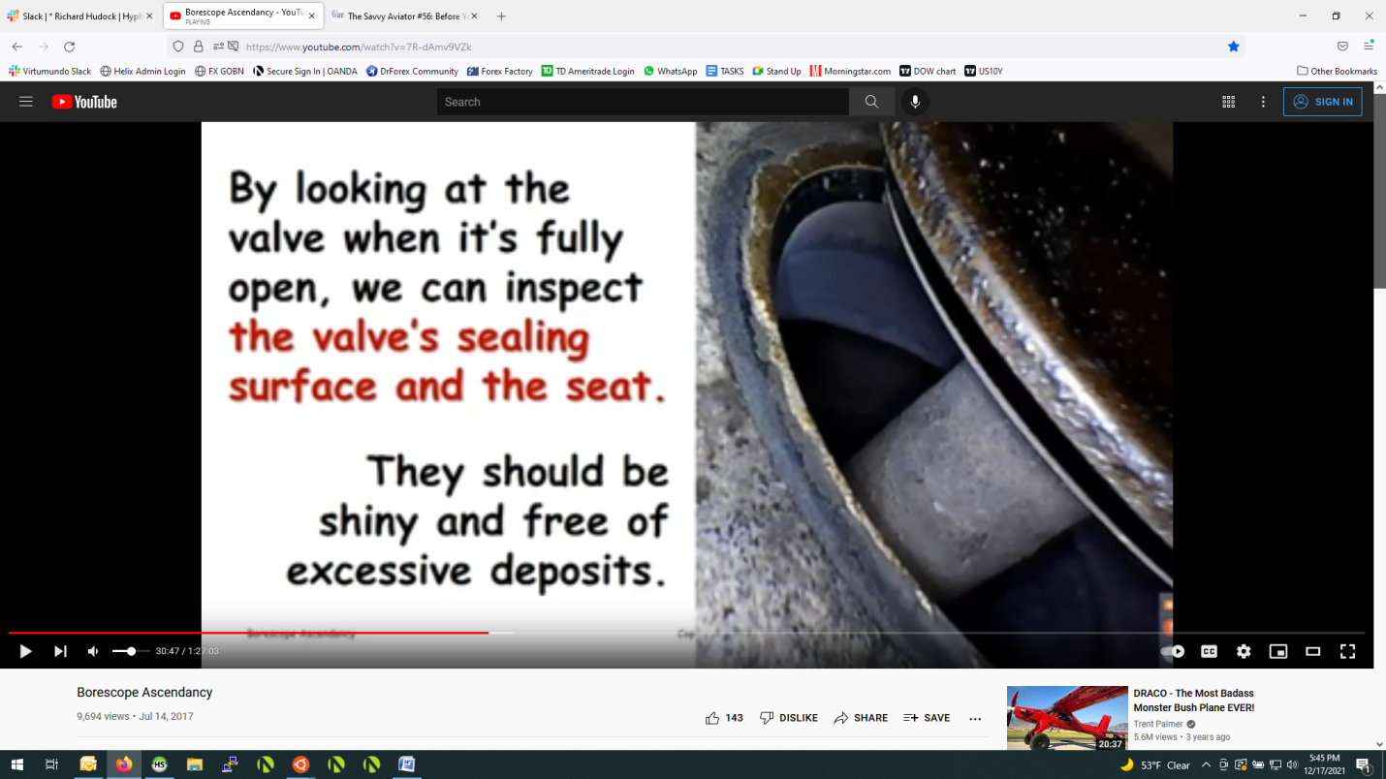
Rotate the prop until the valve opens, then inspect the seating areas. The should be nice and clean and shiny, and free of excess deposits. You typically won’t be able to view the entire 360 degree seating area. The above pic is a good seat. Around the seat tho is mechanic lead, which usually means its been run ROP, especially on Lycoming. Ie, its not uncommon to see this.
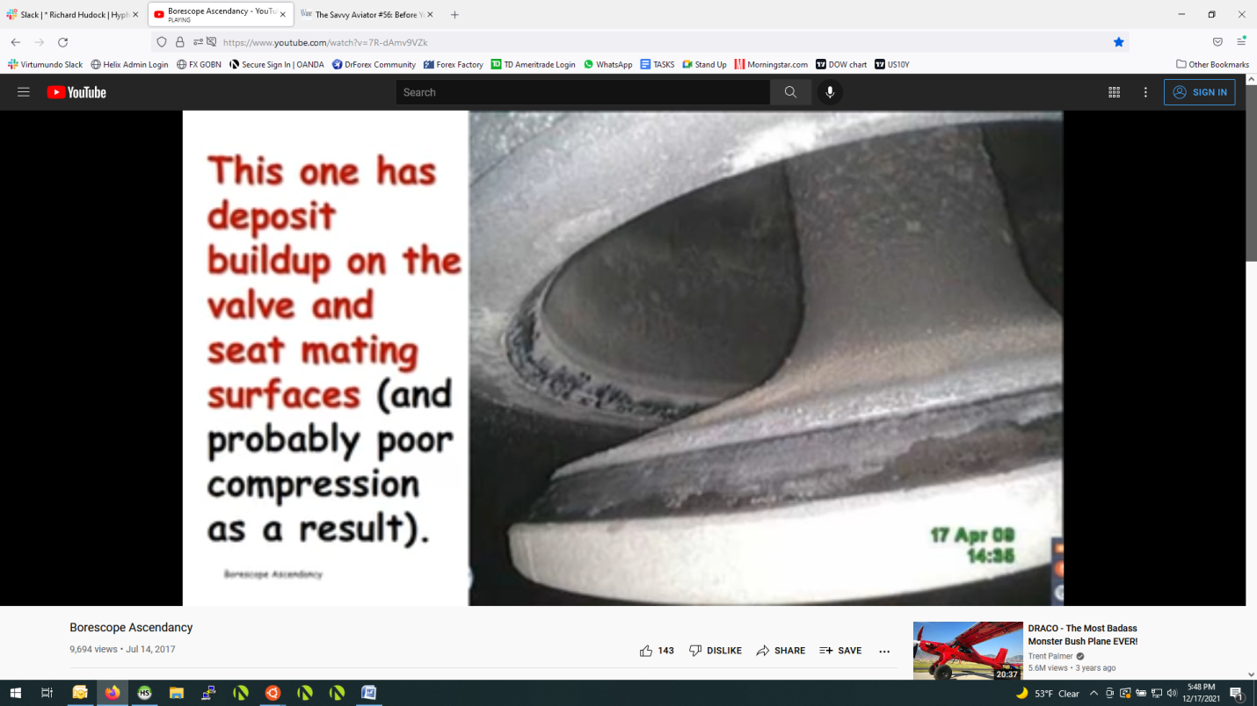This one doesn’t look so good. He called it “moderately contaminated”. The buildup on the sealing surface would most likely show up in low compression readings. If you see this, you can lap it by putting on valve grinding compound and then spinning it until it cleans itself. Not sure exactly how this is done, obviously, but both Mike and Dave from the first set of pics makes it seem very common. Especially in lycomings, you can bring compression readings up.
Usually don’t have problems with intake valves because they run pretty cool. The intake valve is the big one, the exhaust valve is the small one. Spark plugs are on either side. Usually the exhaust valve is the reason you would have to pull a cylinder simply because it runs very hot.
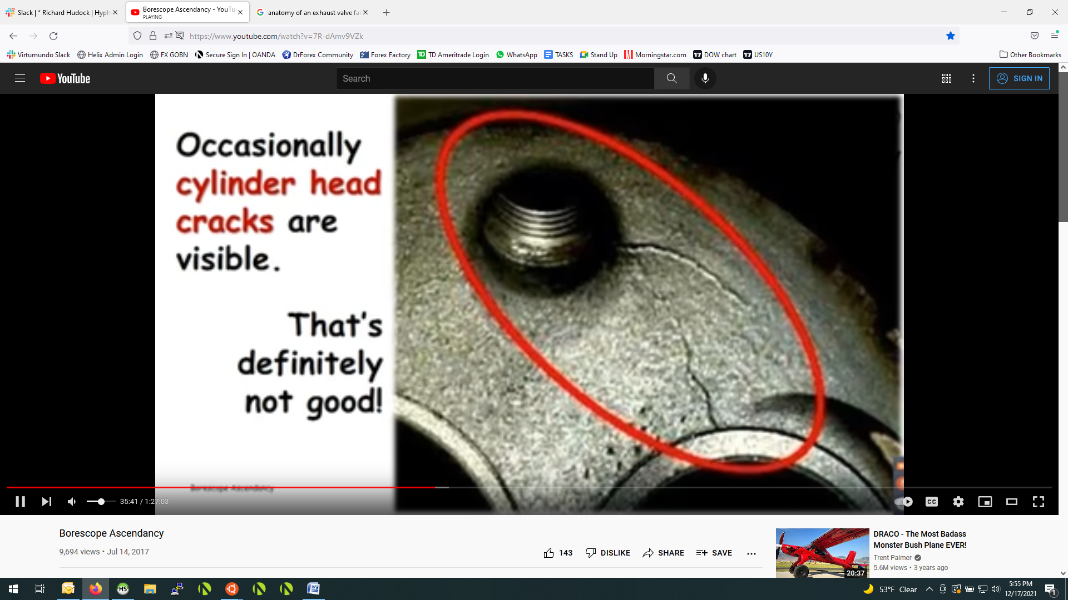
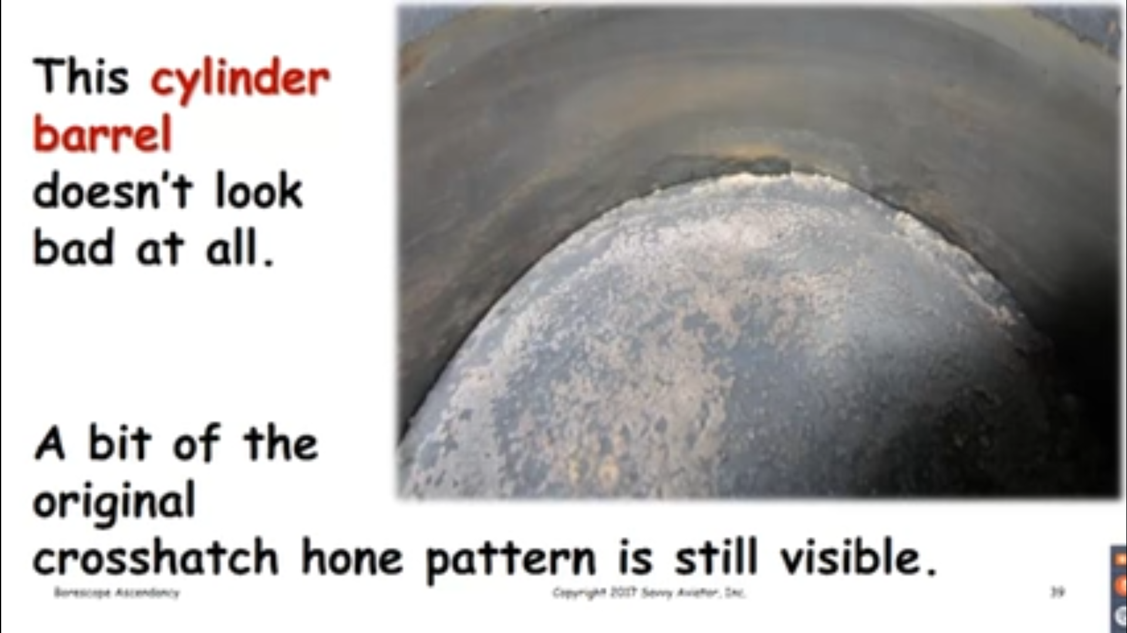You put your borescope at 90 degrees to see this.
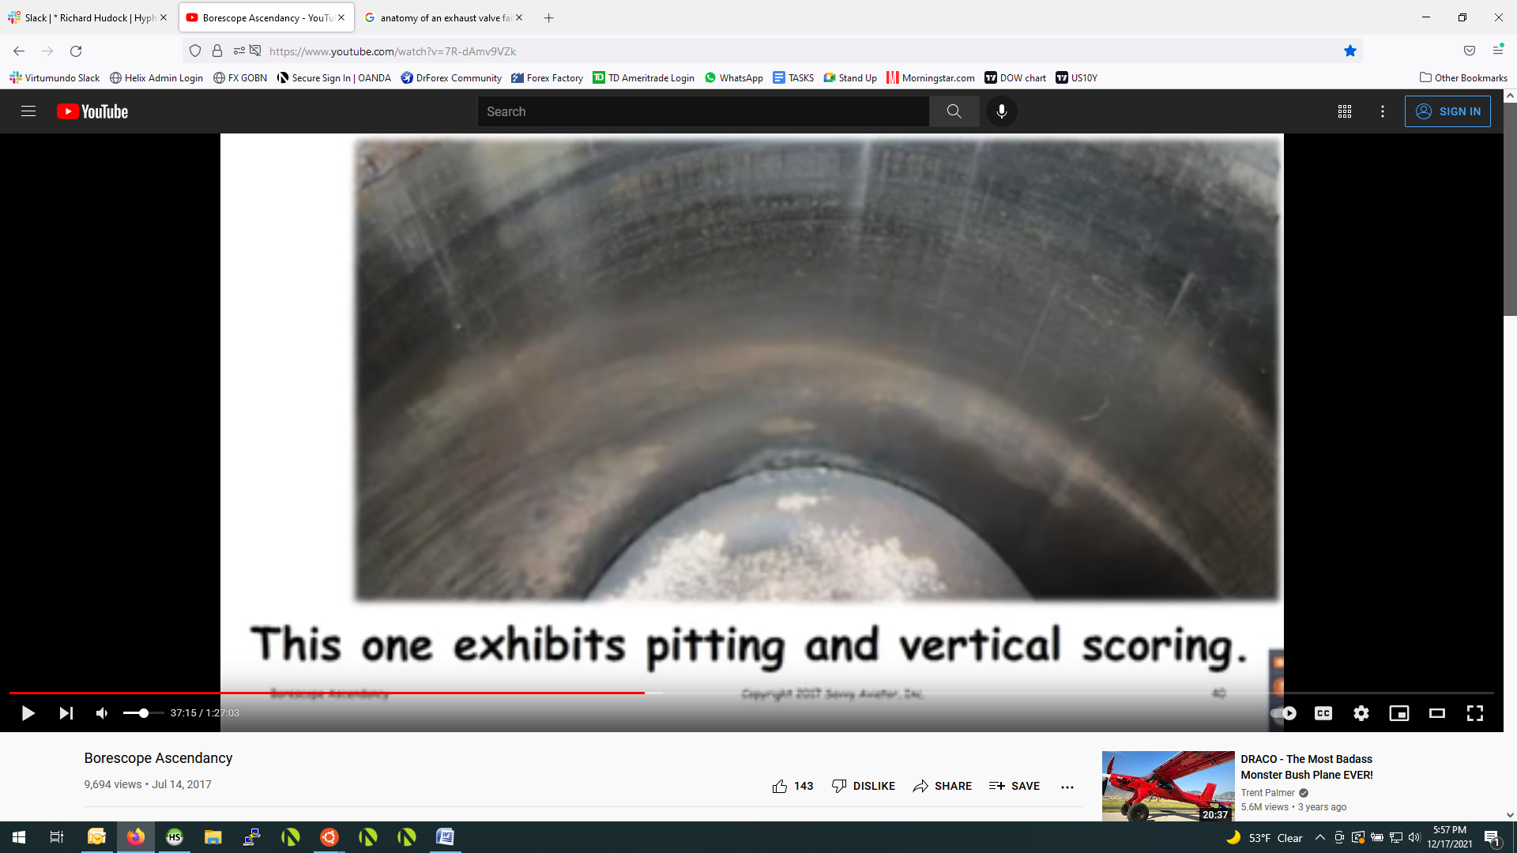
Not necessarily grounds to pull it, unless oil consumption is high, then its definitely a warning sign.
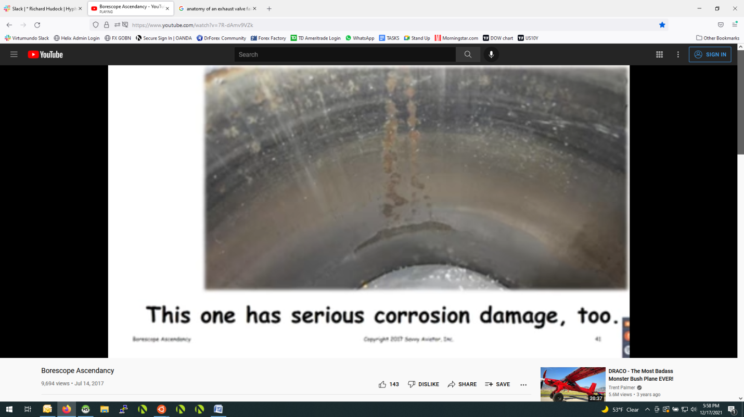
Lot of corrosion and other stuff, mostly from disuse.
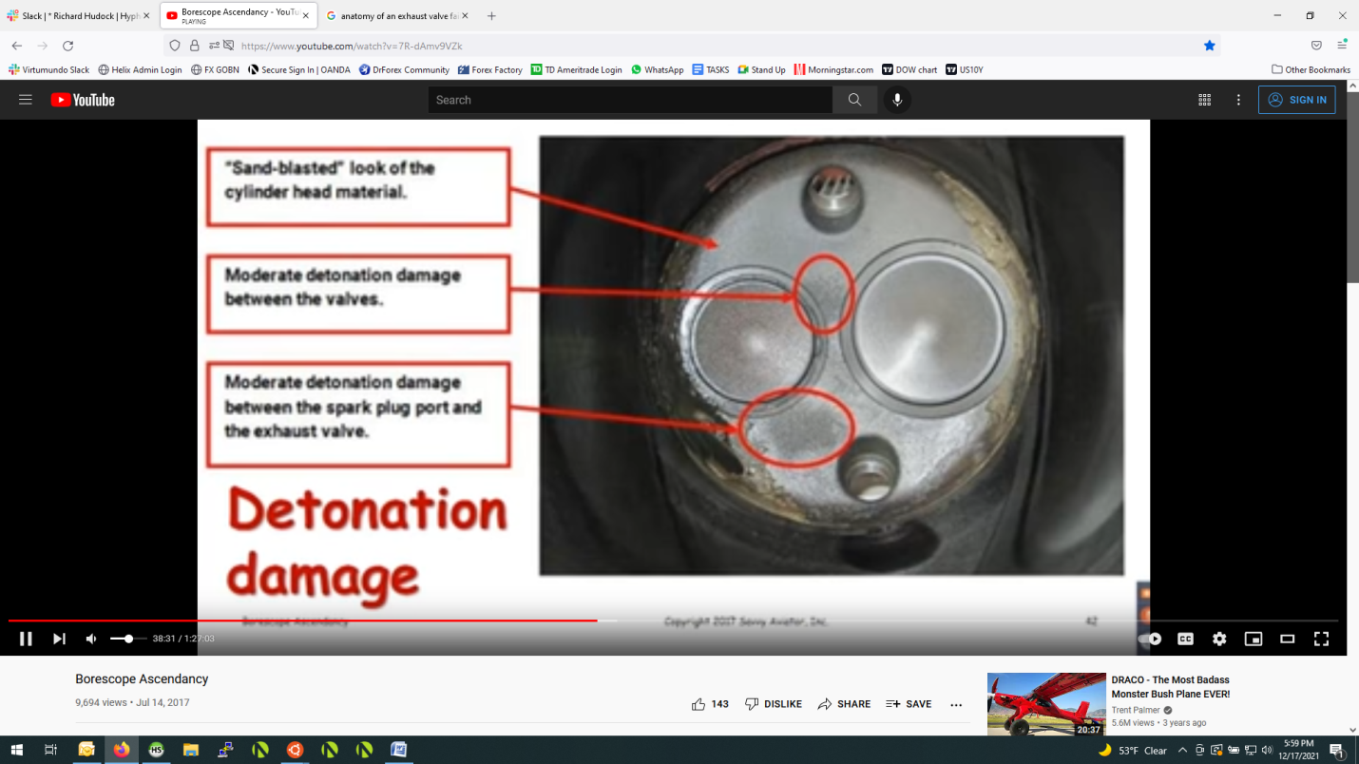
Usually you see the same detonation damage on the crown of the piston as well.
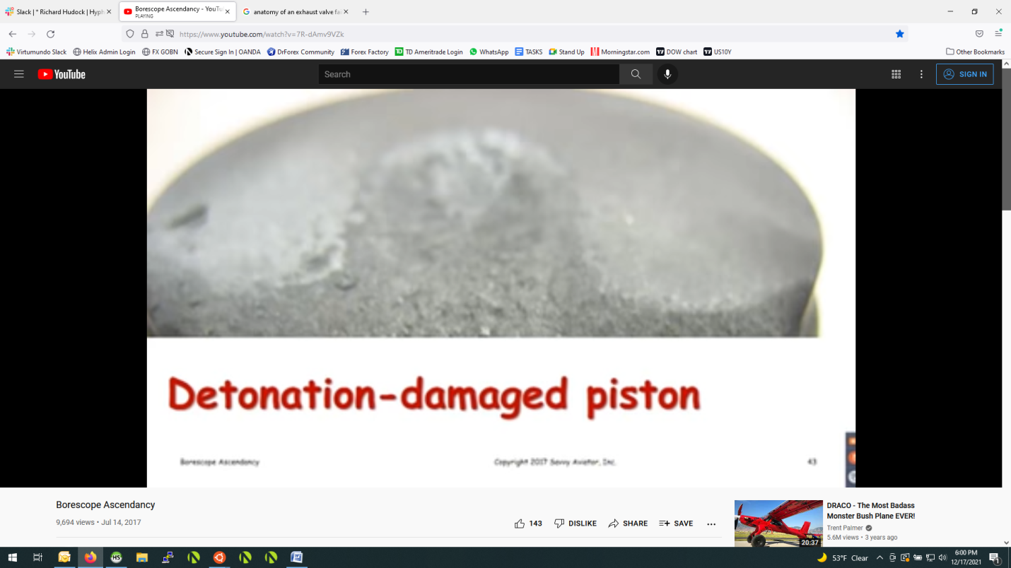
Most likely that cylinder was toast.
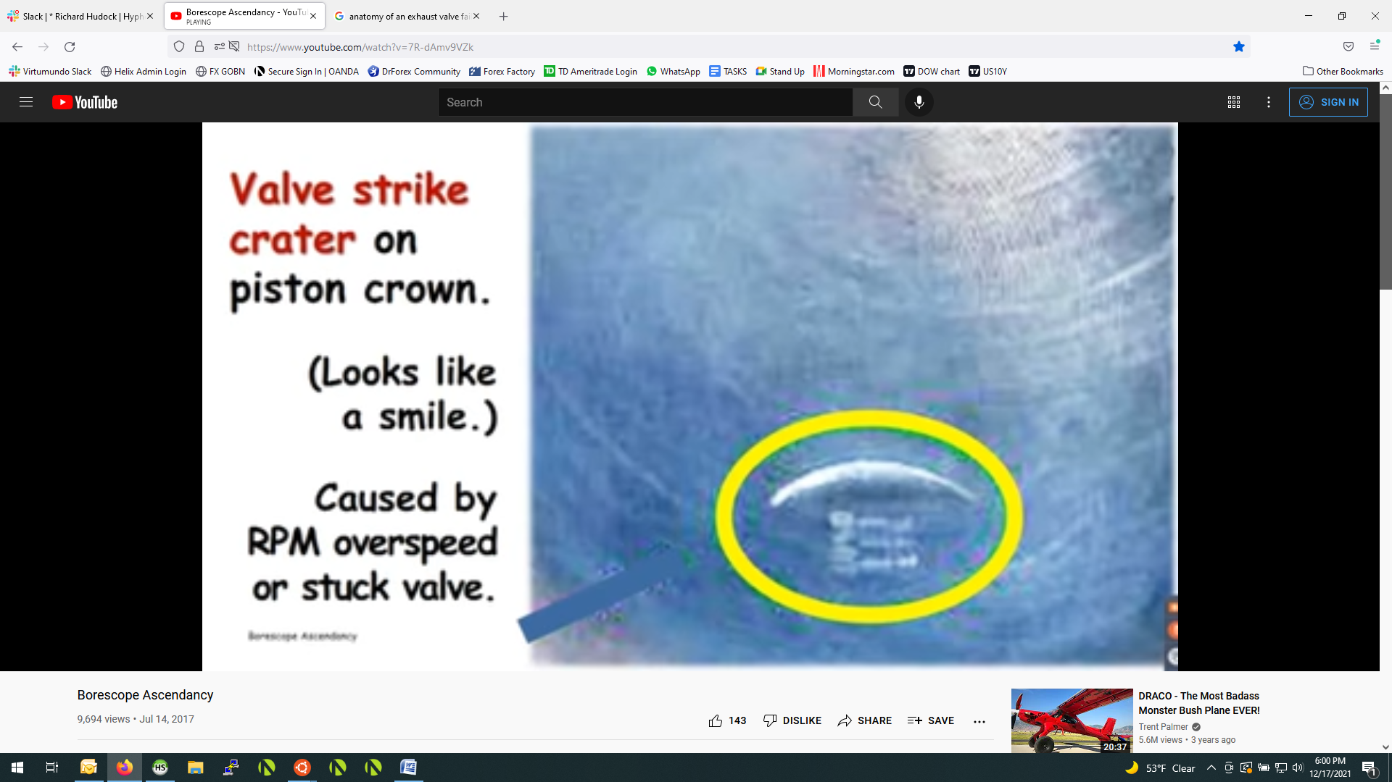
Saw this earlier. Could be stuck valve causing exhaust valve not to close all the way, or due to overspeed. One guy had a big overspeed and was trying to figure out if he needed to tear down the engine. Mike suggested looking for these piston strikes, and if there aren’t any, he probably dodged a bullet.
Borescope far more reliable for cylinder airworthy test than compression testing.
